University Of Engineering and Technology, Lahore
Computer Engineering Department

Course Name: Programming Fundamentals | Course Code: CMPE-112L
Assignment Type: Lab Tasks | Dated: 25-05-2026
Semester: 1st | Session: Spring
Lab/Project/Assignment #: 13 | CLOs to be covered: CLO 2
Lab Title: Map, Filter and Reduce | Teacher Name: Hafiz Muhammad Mubashar
Lab Evaluation:

CLO1 | Apply appropriate programming techniques to create executable programs to solve well defined problems
 | Level1 | Level2 | Level3 | Level4 | Level5 | Level6
(5)
Total |  |  |  |  |  | /5
Rubrics for Current Lab Evaluation
Scale | Marks | Level | Rubric
Excellent | 5 | L1 | Submitted all lab tasks, BONUS task, have good understanding.
Very Good | 4 | L2 | Submitted the lab tasks but have good understanding
Good | 3 | L3 | Submitted the lab tasks but have weak understanding.
Basic | 2 | L4 | Submitted the lab tasks but have no understanding.
Barely Acceptable | 1 | L5 | Submitted only one lab task.
Not Acceptable | 0 | L6 | Did not attempt
LAB No 13
Lab Goals/Objectives:
To learn the use of lambda functions with map(), filter(), and reduce() in Python.
Equipment Required:
Computer or Laptop, Python 3.x, PyCharm or VS Code.
Theory:
Lambda functions are anonymous functions used for short operations. The map() function transforms data, filter() selects data based on a condition, and reduce() combines values into a single result.

Lab Work:
Task 1: Convert Celsius values to Fahrenheit using map().
Result:
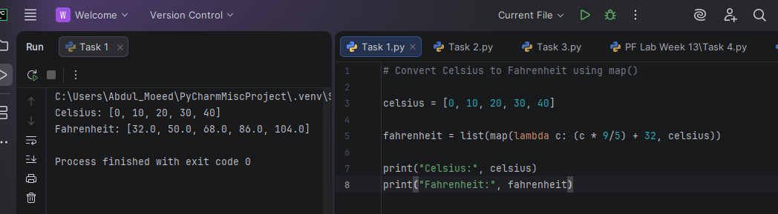

Task 2: Find squares of numbers using map().
Result:
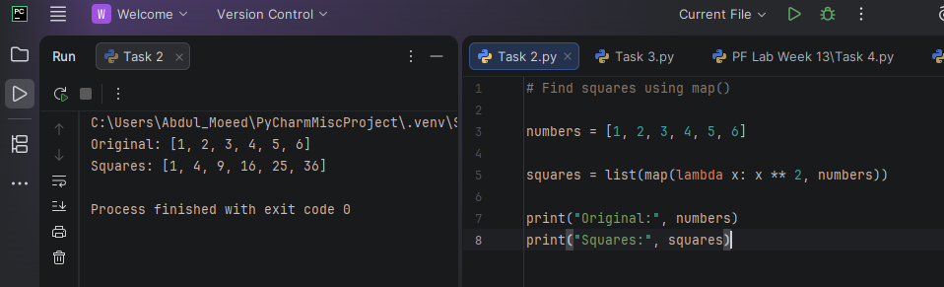

Task 3: Convert names to uppercase using map().
Result:
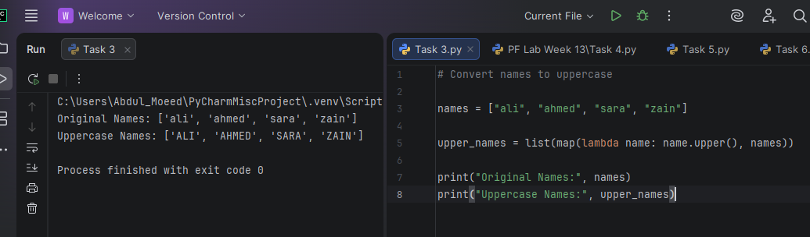

Task 4: Filter even numbers using filter().
Result: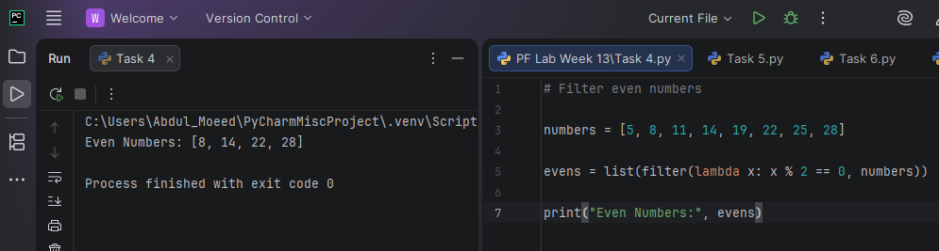

Task 5: Filter marks greater than 50 using filter().
Result:

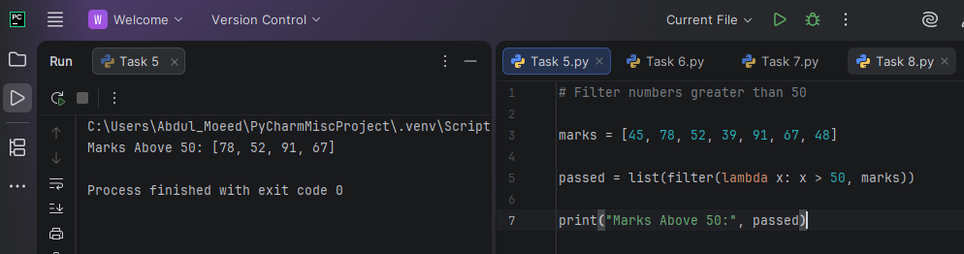

Task 6: Filter positive numbers using filter().
Result:

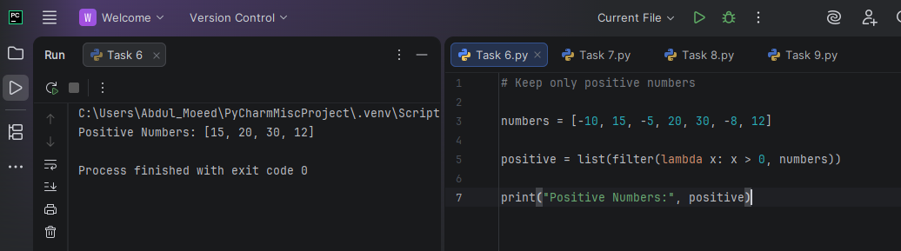

Task 7: Find the sum of numbers using reduce().
Result:
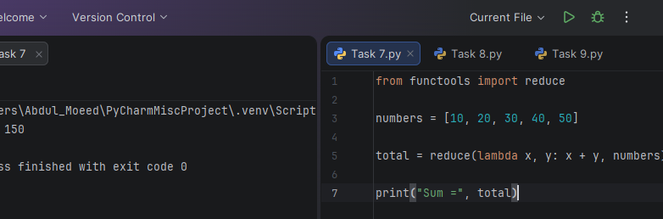

Task 8: Find the product of numbers using reduce().
Result:

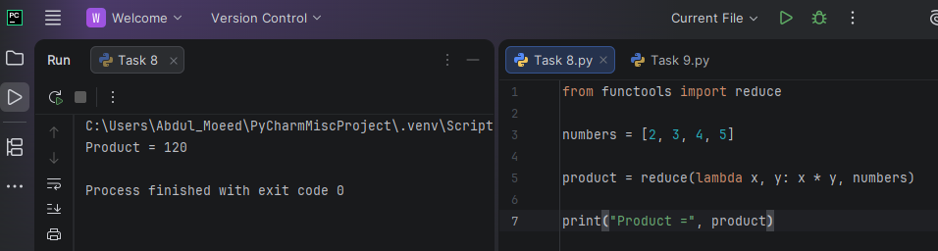

Task 9: Find the maximum number using reduce().
Result:
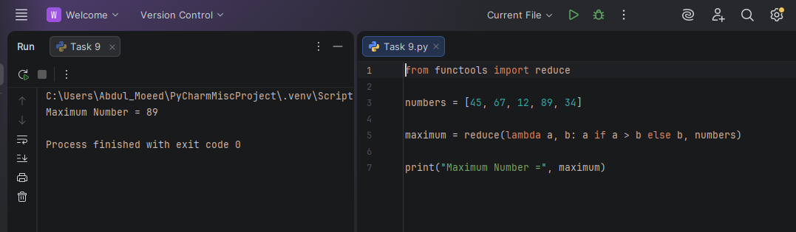

Conclusion:
The lab improved understanding of lambda functions and the use of map(), filter(), and reduce() for data processing in Python.

